Dear HOA Presidents,
Thank you for meeting with us earlier this week to discuss the ongoing issues concerning the trespassing that is taking place on the golf course. We want to convey to the community that this is not a knee jerk reaction, and we have been evaluating the situation over the last year. We have tried to use our golf shop staff as well as our golf course marshals to notify anyone who is on the golf course that should not be there.
As we discussed at the meeting, we are trying to eradicate this activity for two main reasons. We want the members and the guests who are playing to enjoy their experience of Tiger Point Golf Club without interference as well the liability concerns that it presents to the ownership of Tiger Point Golf Club.
In the coming weeks, you will start to see private security patrolling the golf course. You will also see new signage posted around the golf course that will outline what is not allowed. In essence, what is not allowed is anyone that is not a paying customer of Tiger Point Golf Club playing golf at that exact time. This includes:
- Unauthorized Golf Cars
- Pet Walking (No animals are allowed on the golf course)
- Walking/Jogging/Bicycling
- Fishing
- Feeding Animals
- Individuals cutting through the golf course inclusive of current day golfers
We have met with the Santa Rosa County Sheriff’s office and are working on a plan for them to be here on certain days and times to begin enforcement of the rules that are outlined above. By notifying the homeowners associations in advance, our hopes are that this message can be communicated to all residents in hopes that no one will be given any fines. Quite simply, we are looking to provide the best experience for our members, guests, and homeowners to enjoy the golf course during their round of golf.
The only exception to anyone being on the golf course property not playing golf are individuals that are going to and from the tiki bar at their own risk. The only paths that are designated for this are the paths with the blue dorsal fin (TPGC logo) located off of Ganges and Madura. They are marked by the solid blue lines below.
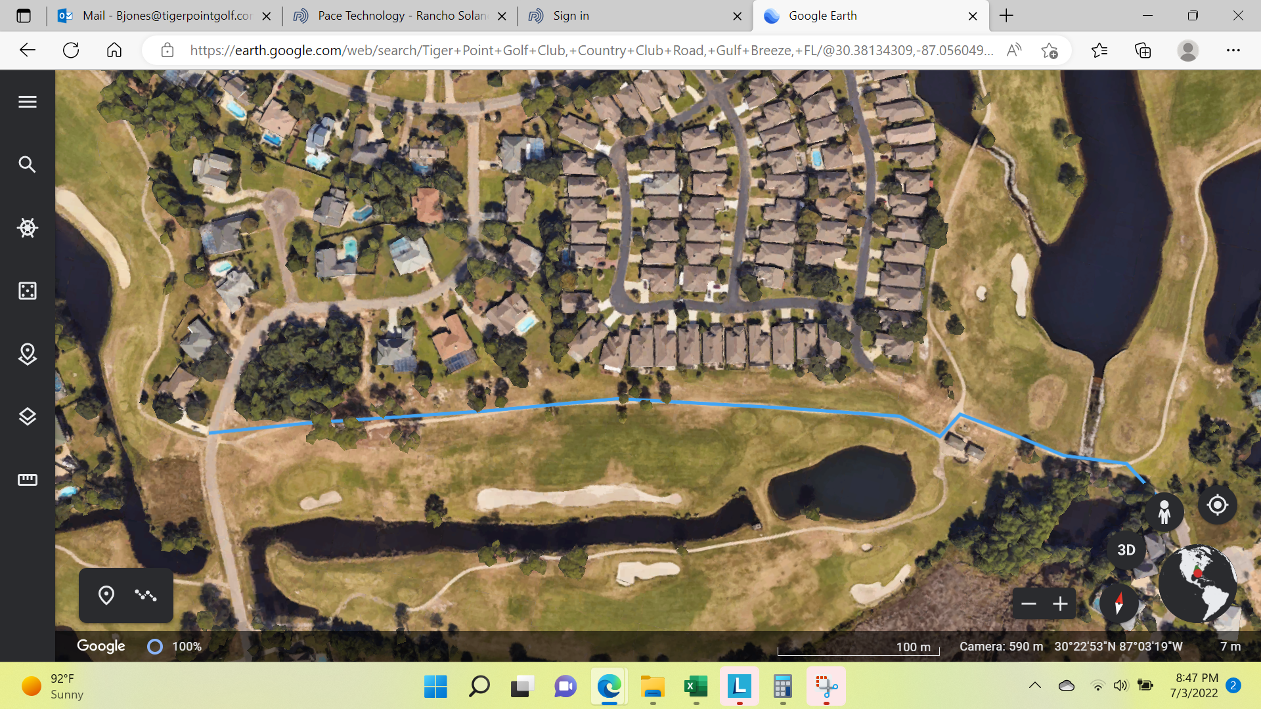

Thank you in advance for your assistance and cooperation. Please feel free to contact me if you have any questions.

Sincerely,

Troy Raybon
850-930-4653
Traybon@tigerpointgolf.com

